Department | AIDS
Course Code / Course Name | DSA0602 / Data Handling and Visualization
Experiment | Data Visualization using R
Name | Ayesha Siddiqa S
Register Number | 192324305
Date | 29 September 2026
Day | Tuesday
LAB EXPERIMENT RECORD
Set 1: Monthly Sales Data

- Aim
To create a line chart in R to visualize the monthly sales and identify the sales trend over the given months.
Short Algorithm
- Create vectors for months and sales.
- Store the data in R.
- Use the plot() function to create a line chart.
- Add suitable axis labels and chart title.
- Display the monthly sales trend.
R Code
# Monthly Sales Data
month <- c("January", "February", "March", "April", "May")
sales <- c(15000, 18000, 22000, 20000, 23000)
# Line Chart
plot(sales,
type = "o",
col = "blue",
xaxt = "n",
xlab = "Month",
ylab = "Sales ($)",
main = "Monthly Sales")
axis(1, at = 1:5, labels = month)
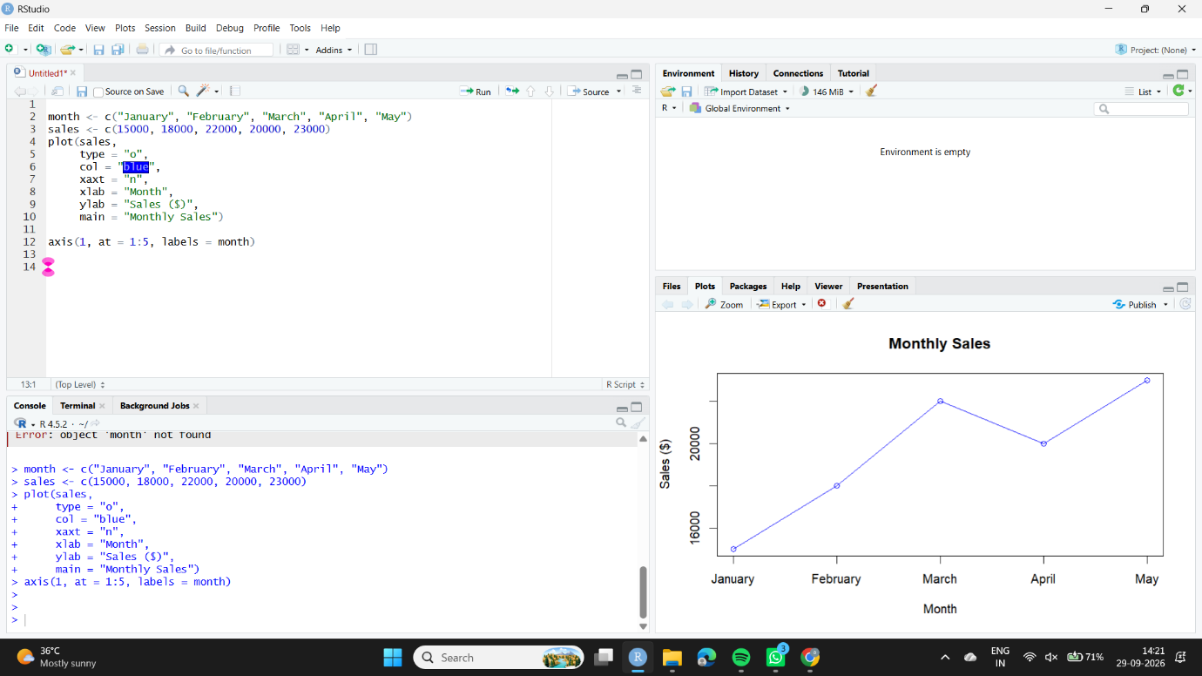
Observation
The line chart shows that sales generally increased from January to May. Sales decreased slightly in April compared to March, but reached the highest value of $23,000 in May.
2: Bar Chart for Top-Selling Products
Aim
To create a bar chart in R to compare the sales of different products and identify the top-selling products.
Short Algorithm
- Create vectors containing product names and their sales.
- Store the product sales data.
- Use the barplot() function.
- Add product names and axis labels.
- Display the bar chart.

R Code
products <- c("Product A", "Product B", "Product C",
"Product D", "Product E")

product_sales <- c(28000, 24000, 22000, 18000, 15000)
barplot(product_sales,
names.arg = products,
col = "green",
xlab = "Products",
ylab = "Sales ($)",
main = "Top-Selling Products")
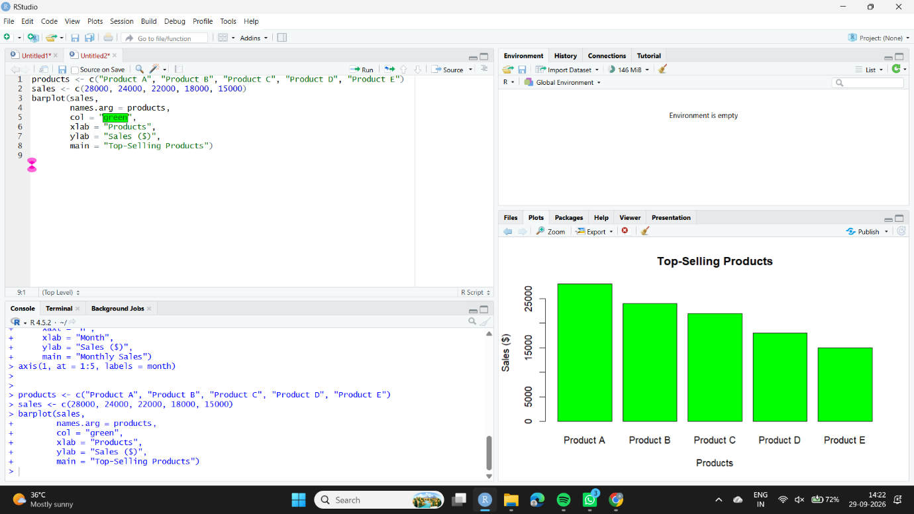
Observation
The bar chart shows that Product A has the highest sales of $28,000, while Product E has the lowest sales of $15,000 among the given products.
3: Scatter Plot – Advertising Budget vs Monthly Sales
Aim
To create a scatter plot in R to analyze the relationship between advertising budget and monthly sales.
Algorithm
- Create vectors for advertising budget and monthly sales.
- Plot advertising budget on the X-axis.
- Plot monthly sales on the Y-axis.
- Add a trend line using linear regression.
- Analyze the relationship between advertising and sales.
R Code
# Advertising Budget and Sales Data
advertising <- c(5000, 7000, 9000, 8000, 10000)
sales <- c(15000, 18000, 22000, 20000, 23000)
plot(advertising, sales,
pch = 19,
col = "red",
xlab = "Advertising Budget ($)",
ylab = "Monthly Sales ($)",
main = "Advertising Budget vs Monthly Sales")
abline(lm(sales ~ advertising),
col = "blue",
lwd = 2)
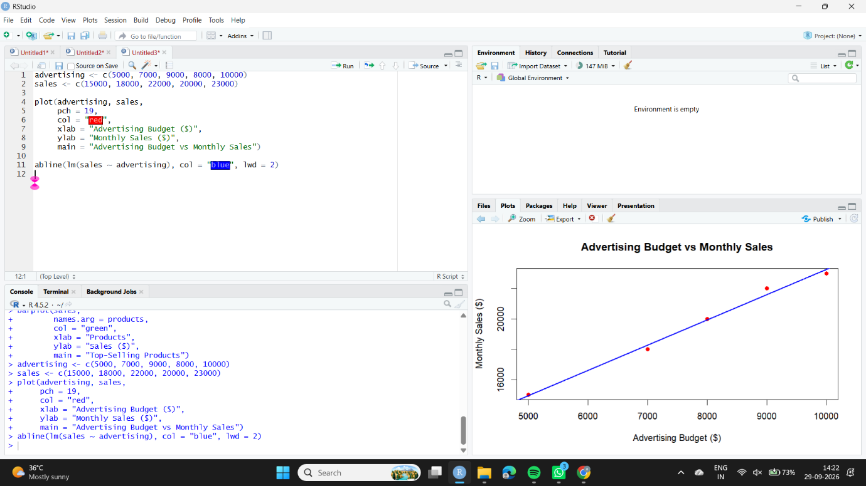
Observation
The scatter plot shows a positive relationship between advertising budget and monthly sales. In general, higher advertising expenditure is associated with higher sales. The trend line indicates the overall direction of this relationship.
4: Interactive Dashboard Using Shiny
Aim
To develop an interactive dashboard in R using Shiny by combining the monthly sales line chart and product sales bar chart.
Algorithm
- Install and load the Shiny package.
- Create monthly sales and product sales datasets.
- Design the user interface with a chart selection option.
- Create the server logic to display the selected chart.
- Run the Shiny application.
- Allow users to switch between the line chart and bar chart.
R Code
# Install Shiny if required
# install.packages("shiny")
library(shiny)
# Monthly Sales Data
month <- c("January", "February", "March", "April", "May")
sales <- c(15000, 18000, 22000, 20000, 23000)
# Product Sales Data
products <- c("Product A", "Product B", "Product C",
"Product D", "Product E")
product_sales <- c(28000, 24000, 22000, 18000, 15000)
# User Interface
ui <- fluidPage(
titlePanel("Monthly Sales Dashboard"),
sidebarLayout(
sidebarPanel(
selectInput("chart",
"Select Chart:",
choices = c("Line Chart", "Bar Chart"))
),
mainPanel(
plotOutput("salesPlot")
)
)
)server <- function(input, output) {
output$salesPlot <- renderPlot({
if (input$chart == "Line Chart") {
plot(sales,
type = "o",
col = "blue",
xaxt = "n",
xlab = "Month",
ylab = "Sales ($)",
main = "Monthly Sales")
axis(1, at = 1:5, labels = month)
} else {
barplot(product_sales,
names.arg = products,
col = "green",
xlab = "Products",
ylab = "Sales ($)",
main = "Top-Selling Products")
}
})
}
shinyApp(ui = ui, server = server)
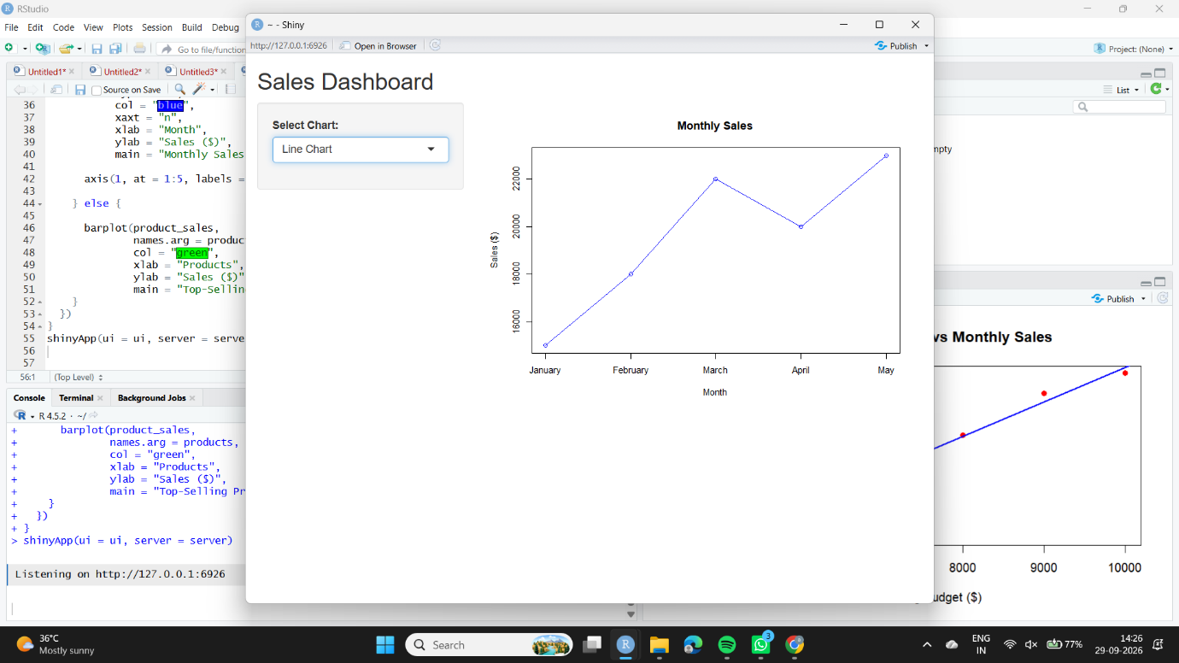
Observation
The Shiny dashboard provides an interactive interface for exploring sales data. Users can select either the Line Chart or Bar Chart from the dropdown menu. The selected visualization is displayed dynamically.

